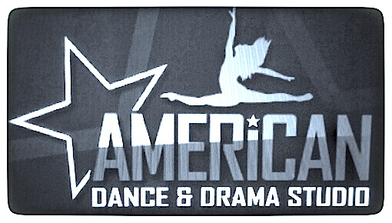

SUMMER SCHEDULE - SINGLE CLASSES - 2016
JULY 5 – AUGUST 12, 2016

TUESDAY

TIME TYPE AGE INSTRUCTOR

5:30pm-6:30pm Hip Hop 7-10 Mr. E
5:30pm-6:30pm Ballet/Tap/Jazz 4-6 Amanda
5:30pm-6:30pm Ballet 6-8 Tanner
5:30pm-6:30pm Acrobatics 9-11 David

6:30pm-7:30pm Acrobatics 6-8 (Level 2) David
6:30pm-7:30pm Tap/Jazz 7-10 Amanda
6:30pm-7:30pm Hip Hop 5-6 Mr. E
6:30pm-7:30pm Ballet 9-11 Tanner

7:30pm-8:30pm Acrobatics 10 + David
7:30pm-8:30pm Hip-Hop 11-14 Mr. E
7:30pm-8:30pm Ballet 12+ Tanner

8:30pm-9:30pm Hip-Hop 15 + Mr. E

WEDNESDAY

TIME TYPE AGE INSTRUCTOR

5:30pm-6:30pm Drama/Vocal 4-7 Jo-Ann
5:30pm-6:30pm Zumba Kids 6 + Angela
5:30pm-6:30pm Hip-Hop 6-8 Arturo

6:30pm-7:30pm Vocal 7 + JoAnn
6:30pm-7:30pm Hip-Hop 9-11 Arturo
6:30pm-7:30pm Ballroom/Latin Kids Fred

7:30pm-8:30pm Tap Adults Jo-Ann
7:30pm-8:30pm Hip Hop 12+ Arturo
7:30pm-8:30pm Zumba Adults Angela

8:30pm-9:30pm Ballroom Adult Fred

THURSDAY

TIME TYPE AGE INSTRUCTOR

5:30pm-6:30 pm Creative Movement 3-4 Amanda

5:30pm-8:30pm Triple Threat 7-11
5:30pm Drama Fred
6:30pm Dance Amanda
7:30pm Vocal Jo-Ann

5:30pm-8:30pm Triple Threat 12 +
5:30pm Dance
6:30pm Vocal Jo-Ann
7:30pm Drama Fred

5:30pm-6:30pm Acrobatics 5-9(Level 1) David
6:30pm-7:30pm Acrobatics 8-11 (Level 2 Company) David
7:30pm-8:30pm Acrobatics 11+ (Level 2 Company) David
8:30pm-9:30pm Acrobatics 11+ (Level 1) David

5:30pm-6:30pm Jazz 9-12 Karina
6:30pm-7:30pm Jazz 6-8 Karina
7:30pm-8:30pm Contemporary 9-12 Karina
8:30pm-9:30pm Contemporary 13+ Karina

7:30pm-9:00pm Drama Adults Fred

American Dance & Drama Studio
188-22 Union Turnpike, Flushing, NY 11366
718-479-8522
www.americandanceanddrama.net
------------------------------------------------------------------------------------------------------------------------
SUMMER SCHEDULE - SINGLE CLASSES - 2016
JULY 5 – AUGUST 12, 2016
20% Discount for classes paid in full by 5/10
(Cash or checks accepted)
Fees for: Six Weeks

1 hour class: $ 108 1.5 hour class for: $ 150 2 hours of classes: $ 180 2.5 hours of classes: $ 228 3 hours of classes: $ 270
3.5 hours of classes: $ 300
4 hours of classes: $ 348
4.5 hours of classes: $ 372
5 hours of classes: $ 390
6 hours of classes: $ 450
7 hours of classes: $ 498 8 hours of classes: $ 547
9 hours of classes: $ 560

-----------------------------------------------------------------

ADULTS

- BALLROOM ADULT SPECIAL RATE: 6 WEEKS FOR $72.00
- ZUMBA: $10 – per class (pay as you go )
- Adult, Hip Hop, Ballet, Tap & Ballroom: $14 per class (pay as you go )
- Private Ballroom/Wedding Dance: $80 per hour or $350 package of 5 lessons.

All classes must be pre-paid in full before the session starts on July 5, 2016. We accept cash; VISA, MasterCard, and Discover Card. There are NO refunds for missed classes and no credits given during the summer session. Any missed 2016 summer classes maybe made up during the 2016 summer session only. Adults 18 + only may pay class at rate of $14 per class for an hour class or $18 – per class for an hour and a half class.

